Bridge
(Structural)

The official definition for the Bridge design pattern introduced by Gang of Four (GoF) is to decouple an abstraction from its implementation so that the two can vary independently.
The implementation of bridge design pattern follows the notion to prefer Composition over inheritance.
Bridge design pattern can be used when both abstraction and implementation can have different hierarchies independently and we want to hide the implementation from the client application.

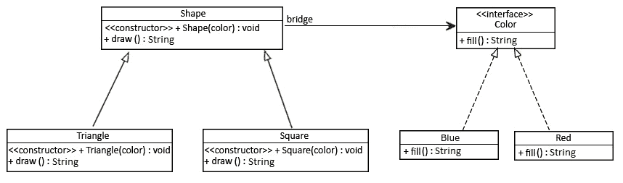

Step 1
public interface Color {
String fill();
}

Step 2
public class Blue implements Color {
@Override
public String fill() {
return "Color is Blue";
}
}

Step 3
public abstract class Shape {
protected Color color;

//standard constructors

abstract public String draw();
}

Step 4
public class Square extends Shape {

public Square(Color color) {
super(color);
}

@Override
public String draw() {
return "Square drawn. " + color.fill();
}
}

Step 5
public class BridgePatternTest {

public static void main(String[] args) {
Shape square = new Square(new Red());
System.out.println(square.draw());

Shape triangle = new Triangle(new Blue());
System.out.println(triangle.draw());
}
}

Output:
Square drawn. Color is Red
Triangle drawn. Color is Blue

Resources:
https://www.baeldung.com/java-bridge-pattern
https://www.digitalocean.com/community/tutorials/bridge-design-pattern-java

